
HEALTH, SAFETY & ENVIRONMENT MANAGEMENT SYSTEM
DAN Construction Safety Manual (DCSM)
Hot Works — Welding, Cutting and Brazing

Document Control
Document No. | 01-000001-000000-DAN-HSE-PRC-000043 | Revision | R01
Issue Date | June 2026 | Classification | Controlled — Internal
Document Owner | HSE Department | Page Format | US Letter

Table of Contents

1. Purpose
2. Scope
3. References
4. Definitions
5. Deliverables
6. General Precautions
7. Hot Work Permit
8. Gas Welding and Cutting
9. Electric Welding and Grounding
10. Fire Prevention
11. Ventilation
12. Protective Equipment
13. Hot Work at Height and in Confined Spaces
14. Periodic Inspection / Records
15. Related Documents
Figures and Illustrations
Revision History

1. Purpose
This document provides DAN requirements to ensure safe welding, cutting and brazing operations (hot work) on DAN projects.

2. Scope
This document applies to all hot work on DAN projects — gas and electric welding and cutting, grounding, fire prevention, ventilation, PPE, and hot work at height and in confined spaces — and to the Hot Work Permit system that controls it.

3. References
- 29 CFR 1910 Subpart Q; 29 CFR 1926 Subpart J — Welding and Cutting; EM 385-1-1, Section 10
- ANSI/AWS Z49.1 — Safety in Welding, Cutting and Allied Processes; ANSI/ISEA Z87.1; NFPA 70 (NEC)
- ACGIH Threshold Limit Values
- DCSM — Fire Protection and Prevention; DCSM — Confined Spaces; DCSM — Personal Protective Equipment; DCSM — Hazard Communication

4. Definitions
Term | Definition
Hot Work | Any operation producing heat, sparks or open flame — welding, cutting, brazing, grinding or heating.
Hot Work Permit | A written authorisation issued by the SH&E Representative confirming precautions are in place before hot work begins.
Fire Watch | A trained person who watches for fire during and after hot work and is equipped to extinguish or raise the alarm.
Flashback Arrestor | A device that prevents a flame front travelling back into the hose/regulator of a gas welding/cutting set.
LFL | Lower Flammable Limit.

5. Deliverables
- Hot Work Procedures
- Hot Work Permits
- Hot work register/log

6. General Precautions
- Welding and cutting shall be performed only by experienced, properly trained persons; AHAs describe the safe practices, fire prevention, PPE and equipment required.
- All tools and equipment shall be inspected before use; worn or damaged hoses, leads or defective equipment shall not be used and shall be reported and repaired.
- Welders and helpers shall not carry matches when welding/cutting, shall keep passageways/ladders/stairways clear of cables and hoses, and shall barricade or warn of the area after operations.
- Before welding/cutting/heating any material with a coating of unknown flammability, the qualified person shall test it; highly flammable coatings shall be removed and the surface stripped at least 4 in (10 cm) on each side of the cut/weld, with additional precautions where coatings are toxic.
- In dusty or gaseous spaces where an explosion is possible, hot work shall not be used until the space is adequately ventilated; enclosed-space hot work shall conform to the Confined Spaces chapter; open-air personnel shall be protected by respirator or adequate ventilation.

7. Hot Work Permit
- No hot work shall be carried out except after obtaining a written Hot Work Permit from the SH&E Representative; permits are controlled by the Contractor's Health & Safety department, which maintains a register/log of all hot work.
- A permit shall not exceed the shift for which it was issued (workshops may extend validity to one week subject to risk assessment); supervisors complete and submit a permit each shift for hot work outside designated welding areas.
- The Site SH&E Representative reviews and approves the permit only after checking the work area and testing for flammable gases, dust and oxygen; the person performing the work examines and signs for the worksite before starting.
- The permit is posted conspicuously at the worksite; the Representative inspects before approval, suspends work when necessary, and visits periodically; the permit becomes void at the end of each shift or when conditions change significantly unless re-approved in writing.

8. Gas Welding and Cutting
- Use only approved equipment; handle and store cylinders per the Hazardous Materials chapter; use approved backflow check valves in both gas and oxygen lines and flashback arrestors on all lines at the gauges, with check valves between hose and torch.
- Do not repair welding hose with tape, take cylinders into confined spaces, support work on cylinders, or weld/cut/grind on drums or hollow structures that have held toxic/flammable substances until cleaned, purged and gas-tested; do not perform inert-gas metal-arc welding within 200 ft (61 m) of chlorinated-solvent use.
- Keep cylinders, caps, valves, regulators, hoses and fittings free of grit, grease and oil; close cylinder valves when unattended; fit correct regulators and check them regularly; use brass (never copper) connections/regulators with acetylene.
- When "cracking" a cylinder valve, stand to one side (not in front) and not near ignition sources; oxygen cylinders shall not be handled with oily hands/gloves and oxygen shall never contact oily surfaces.
- Inspect cylinders, valves, regulators, gauges, fittings and hoses for damage and leaks (soapy water) before use; a leaking cylinder shall be tagged, moved to a safe area and returned to the supplier; keep cylinders upright with hand trucks/chains and transport/store/use them vertically.
- Fuel-gas and oxygen hoses shall be different colours and not interchanged; hose connections shall be made by compression clips/crimps — jubilee/worm-drive clamps are PROHIBITED; keep the torch nozzle closed when not in use, never leave a lighted torch unattended, light with a friction striker (not matches/lighters), and turn off cylinders and bleed hoses at the end of each shift.

9. Electric Welding and Grounding
- Use only approved equipment per the manufacturer's instructions and properly ground the machine; do not strike an arc where nearby persons may be affected; remove electrodes from unattended holders and protect the holders from contact.
- Open the power supply switch when leaving work for more than 1 hour or moving the machine; stand on a dry, non-conductive platform, never in water or in the rain; use DC where shock risk is extreme (damp/confined spaces); never dip holders in water to cool them.
- Welding-machine electrical outlets shall be 110 V maximum with GFCIs (220 V outlets disabled); electrode holders shall be rated for the current and fully insulated; do not place electrodes inside scaffold tubes.
- Frames of all arc-welding machines shall be grounded; ground returns shall be securely attached close (1–4 m) to the weld, never to piping containing flammable gases/liquids or conduit with electrical circuits; welding current returns by a single cable from work to machine.
- Splices are not allowed in welding cables, which shall be continuous for at least 10 ft (3 m) from the holder end; damage beyond 10 ft shall be repaired with a standard plug-and-socket coupling (electrical-tape repairs are prohibited); cables shall be inspected, elevated or protected, and damaged cables removed from service.

10. Fire Prevention
- Welding areas shall be free of combustible/flammable materials, verified by gas monitor — the LFL reading shall not exceed 10% before welding begins; where possible, perform hot work in designated, non-combustible areas free of combustibles.
- Move combustible materials to a safe distance or protect them with a fire-resistant shield/blanket; cover openings or cracks in adjacent walls with fire-resistant covers to prevent passage of sparks; do not weld in explosive atmospheres.
- A fire watch shall be on duty during operations and for at least 1/2 hour afterward to detect smouldering fires, provided with fire-protection equipment, PPE and communication equipment, familiar with raising the alarm; after completion, the immediate area shall be checked free of fire.
Note: For further information on flammable and combustible liquids, refer to the Fire Protection and Prevention chapter.

11. Ventilation
Proper ventilation (natural or mechanical) shall be provided to dilute or remove fumes and vapours from the breathing zone, keeping airborne contaminants below ACGIH Threshold Limit Values / PELs. General mechanical or local exhaust ventilation shall be used when welding, cutting or heating zinc-, lead-, cadmium- or chromium-bearing materials in any enclosed space; local exhaust ventilation or airline respirators shall be used for lead-, cadmium- or mercury-coated metals; and both local exhaust and airline respirators are required for beryllium. Contaminated exhaust shall be discharged to open air, away from intake air. Refer to the Project Hazard Communication Plan for the listed hazardous materials.

12. Protective Equipment
- Personnel welding/cutting and others present shall be protected against radiation, flying sparks, glare, molten material and slag by proper PPE; the welder wears an approved helmet/goggles with the correct lens shade, and helpers wear eye protection under the face shield, with secondary eye protection when the helmet is raised.
- Welders shall wear long sleeves or leathers (buttoned, avoiding cuffs/top pockets) and welding gloves; additional PPE may include aprons, capes/shoulder covers/skullcaps for overhead welding, fire-resistant leggings/high boots and fire-retardant clothing; adjacent personnel shall be protected by non-combustible screens or appropriate eye/face protection.
- Where ventilation does not prevent overexposure, an approved air-purifying or airline respirator shall be used against metal fumes (zinc, lead, mercury, cadmium, manganese hard-facing, beryllium/exotic metals, stainless-steel cutting).

13. Hot Work at Height and in Confined Spaces
- 100% fall protection is required on all platforms, ladders, scaffolds or runways over 6 ft (1.83 m): a full-body harness with shock-absorbing lanyard tied off to an anchor capable of supporting 5,000 lb.
- Hot work in a confined space requires strict adherence to the Confined Spaces chapter — training, air monitoring, ventilation and a Hot Work Permit; lifelines (without entanglement hazard) shall be used through vertical/small openings, with rescue procedures listed on the permit, and the Attendant and Fire Watch shall not be the same person unless fire-watching can be done from outside.
- Cylinders and welding machines shall be located outside the space and secured; remove the electrode when work is suspended; thoroughly clean used drums/tanks of greases/tars/acids and blank connected pipelines before hot work; close torch valves and shut off gas outside the space (removing torch/hose where practicable) during interruptions.
Note: Because of its high toxicity, both local exhaust ventilation and airline respirators are required when working with beryllium.

14. Periodic Inspection / Records
Welding equipment shall be visually inspected before use on each shift; defective equipment shall be removed from service until repaired and tested. The Site Safety Representative confirms the work area is inspected before a permit is issued and checks periodically that permit conditions are maintained. Permits, the hot-work register, inspection and training records shall be maintained on-site and archived at project close.

15. Related Documents
- DCSM — Fire Protection and Prevention
- DCSM — Confined Spaces
- DCSM — Personal Protective Equipment
- DCSM — Hazard Communication

Figures and Illustrations
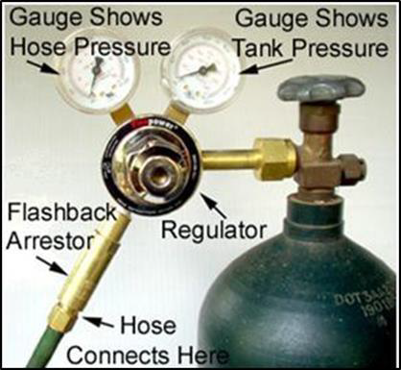
Figure 43-1 Example Cylinder with Flashback Arrestor
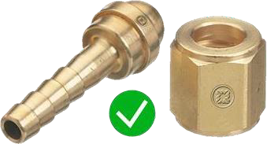
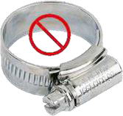
Figure 43-3 PROHIBITED Clip/Clamp
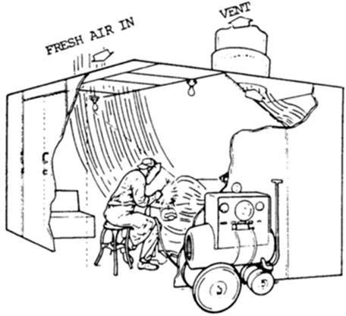
Figure 43-4 General Mechanical Ventilation
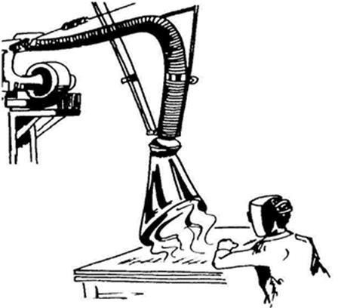
Figure 43-5 Local Exhaust Ventilation

Revision History
Rev. | Date | Description of Change | Approved By
R00 | June 2026 | Initial issue. Restructured to the DAN integrated HSSE management-system template and re-branded in accordance with the DAN Brand Book. | Project Director
R01 | June 2026 | Re-coded to the updated DAN document-numbering convention (01-000001-000000-DAN-{discipline}-{type}-{seq}). | Project Director

